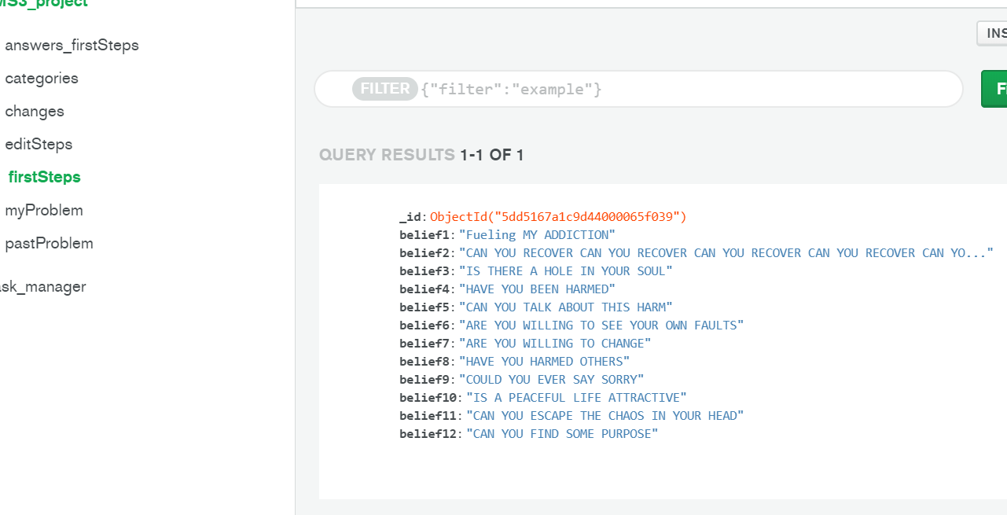

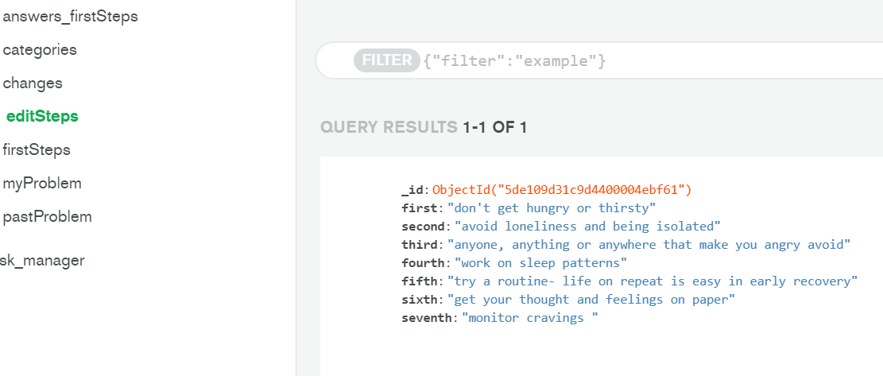

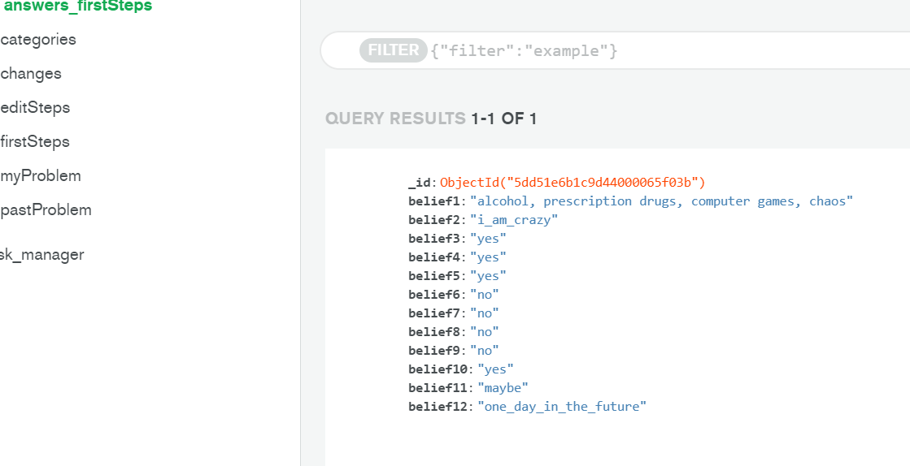
{% extends 'base.html' %}
{% block content %}

<ul class="collapsible">

{% for firstSteps in firstSteps %}
<li>
<div class="collapsible-header">
<div class=" task_header col s9">
<i class="material-icons">expand_more</i>
<strong>{{firstSteps.belief1}}</strong> - {{firstSteps.belief2}}
</div>
</div>

<div class="collapsible-body">
<span>
{{firstSteps.belief3}}
{{firstSteps.belief4}}
{{firstSteps.belief5}}
{{firstSteps.belief6}}
{{firstSteps.belief7}}
{{firstSteps.belief8}}
{{firstSteps.belief9}}
{{firstSteps.belief10}}
{{firstSteps.belief11}}
{{firstSteps.belief12}}
</span>
</div>

<div class="collapsible-body">
<span>
{{firstSteps.belief3}}
{{firstSteps.belief4}}
{{firstSteps.belief5}}
{{firstSteps.belief6}}
{{firstSteps.belief7}}
{{firstSteps.belief8}}
{{firstSteps.belief9}}
{{firstSteps.belief10}}
{{firstSteps.belief11}}
{{firstSteps.belief12}}
</span>
</div>

<div class="collapsible-header">
<div class=" task_header col s9">
<i class="material-icons">expand_more</i><strong>{{firstSteps.belief1}}</strong> - {{firstSteps.belief2}}
</div>
</div>

<div class="collapsible-body">
<span>
{{firstSteps.belief3}}
{{firstSteps.belief4}}
{{firstSteps.belief5}}
{{firstSteps.belief6}}
{{firstSteps.belief7}}
{{firstSteps.belief8}}
{{firstSteps.belief9}}
{{firstSteps.belief10}}
{{firstSteps.belief11}}
{{firstSteps.belief12}}
</span>
</div>

<div class="collapsible-body">
<span>
{{firstSteps.belief3}}
{{firstSteps.belief4}}
{{firstSteps.belief5}}
{{firstSteps.belief6}}
{{firstSteps.belief7}}
{{firstSteps.belief8}}
{{firstSteps.belief9}}
{{firstSteps.belief10}}
{{firstSteps.belief11}}
{{firstSteps.belief12}}
</span>
</div>
</li>
{% endfor %} </ul>

{% endblock %}v

